Group Merchandise Order Form (Staff)
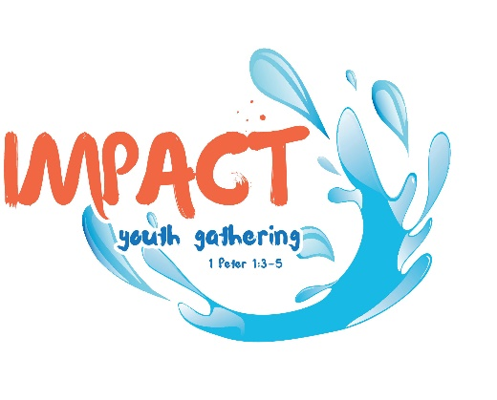
Deadline for ordering: May 1, 2026
Send completed form to: sonjabland70@gmail.com

Either bring your merchandise cheque to the IMPACT Youth Gathering and give it to the Registrar when you check in, or mail it in to the church with the rest of your registration paperwork by mid-June.
Cheques should be payable to “Lutheran Church–Canada” with “IMPACT Youth Gathering merch” in the memo line.
Your group’s order will be available to pick up at the gathering.

Congregation: ________________________________
7 + 1 Leader: _________________________________
Contact Phone # ______________________________
Contact Email ________________________________

T-shirts and hoodies will come in a variety of colours with the IMPACT logo on the front. Both are pre-shrunk cotton made in Canada.
T-Shirt colour options are: Fatigue Green, Maroon, and Navy
Hoodie colour options are: Forest Green (Note this is a darker green than the t-shirt option), Maroon, and Navy
See the last page for sizing charts – all sizes are adult unisex.
On the order form indicate the size, the quantity, and colour choice.
IMPACT staff will automatically be provided with a light blue t-shirt in the size indicated on their registration form;
however, staff may purchase their own t-shirts in other colours, and/or hoodies in other colours or in the staff blue.
Staff blue hoodies are not provided.

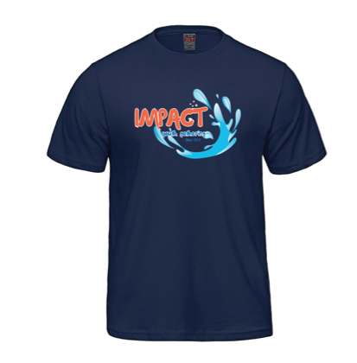
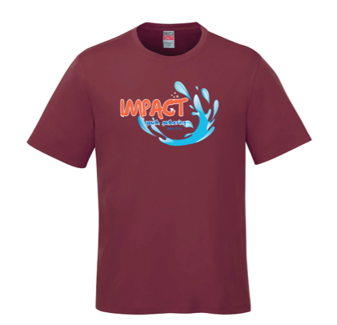
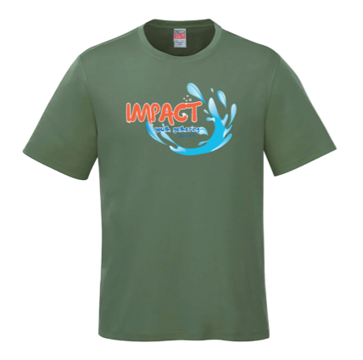

Fatigue Green Maroon Navy

T-Shirt Order
Size | Quantity | Cost/T-shirt | Fatigue  Green | Maroon | Navy | Total Cost
XS |  | $20
S |  | $20
M |  | $20
L |  | $20
XL |  | $20
2XL |  | $23
3XL |  | $23
4XL |  | $23
 | Total Cost
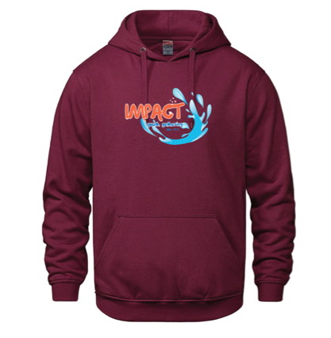
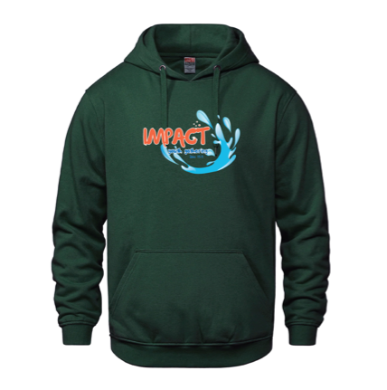
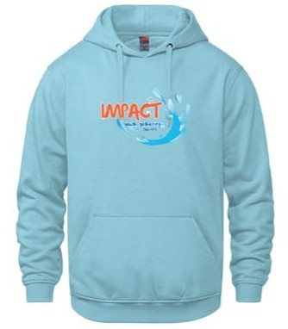
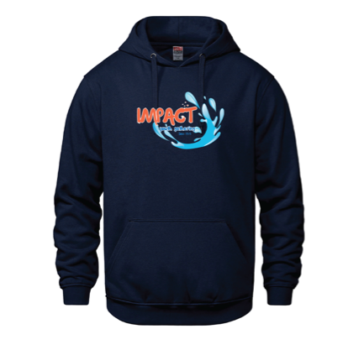
Forest Green Maroon Navy Light Blue

Hoodie Order
Size | Quantity | Cost  Hoodie | Forest  Green | Maroon | Navy | Light Blue | Total Cost
XS |  | $37
S |  | $37
M |  | $37
L |  | $37
XL |  | $37
2XL |  | $40
3XL |  | $40
4XL |  | $40
 | Total Cost

